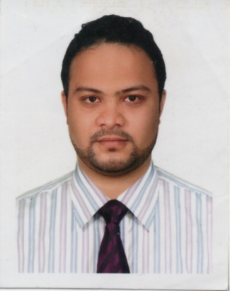

**Mohammed Rukon Uddin**

**HP: +601151137734**

E-mail: [m_rukon@hotmail.com](mailto:m_rukon@hotmail.com),

**Skype ID**: m_rukon1

**Job Objectives:** To be a member of leading organisation which is providing value added services to bring quality in life and where I can utilize my skills, technical and analytical ability to deliver quality output.

**Personal Details: __________________________________________________________________**

* Country of Citizen: Peoples Republic of Bangladesh
* Date of Birth: 10th August 1990
* Language: Rohingya, English, Bengali, some hindi and some Malay

**Profile Summary: ­­­­________________________________________________________________**

* An enterprising individual with good interpersonal skills and high willingness to learn.
* Have a good communication skill with an effective manner.
* Deft in handling priorities, with a bias for action and a genuine interest in personal and professional development.
* Well organised with a track record that demonstrate self motivation, creativity and initiative to achieve both corporate and personal goals.
* Polite, patience, loyal, dedicated and explorative minda

**Academic Certifications: ___________________________________________________________**

* Secondary School Certificate from Public School in 2005
* Higher Secondary Certificate from Public College in 2007
* Certificate in English Advance Level from Westminster International College in 2011
* Bachelor of Arts. (hons.) Business Studies, A degree from Cardiff Metropolitan University UK collaborated with Westminster International College Malaysia in 2014.
* Masters of Business Administration (Running), **PUTRA BUSINESS SCHOOL, University Putra Malaysia (UPM).**

**Additional Certified Training Program:___________________________________________**

* Cairo Community Interpreter Project (CCIP) Introductory Training in **Community Interpreting for Migrant, Asylum-Seeking, and Refugee Settings**. (50 hours Training)
* Cairo Community Interpreter Project (CCIP) Special Training in **Community Interpreting for Mental Health and Gender-Based Violence in Migrant, Asylum-Seeking, and Refugee Settings**. (20 hours Training)

**Scholarship rewards:­_______________________________________________________________**

* Scholarship for students in Bachelor of Arts (hons.) Business Studies (final Year 2013-2014) by Diyanet Foundation, Turkey.

**Experience:______________________________________________________________________**

* Staff Trainer (Training and Development) (2012-2013) @ Coffee Chemistry Signature, Kuala lumpur, Malaysia
* Part-Time interpreter 2015 for Rohingya Cases (Sep-Dec) @ Asylum Access Malaysia.

**Technical Knowledge Preview: ______________________________________________________**

* Applications: Microsoft Office (Word, PowerPoint, Excel). Browsing and Web Research.

**Personal Interest: __________________________________________________________________**

* Willingness to be updated with daily news, Reading,Travelling, Surfing net, Physical exercise.